**Running SQP OP CLI 1.0:**

**Preface:**

1. **Purpose**

The purpose of this Command Line Interface (CLI) is to provide API support for the Test Management Platform (TMP). With this, users can sends test cases to SQP without having to use SQP’s GUI.

1. **Contents of Zipped File**   
   FileName: SQPCLI_1.0  
   Location: \\lscfs02\LDC-svsw27\Document-Lib\fphillip\SQP\SQP_OP\release\SQPCLI_1.0   
     
   Contents:  
   **Frank**: This directory contains the mult8x8 testcase   
   **lib**: contains sqp program’s **lib**raries   
   **res**: contains external **res**ources required by sqp such as the trunk script and ftdi.exe to send data to the connected board  
   **input.txt:** input file to run SQP (will be explained later on)  
   **sqp.jar**: The SQP CLI program  
     
   **Note:** res and lib folder must be in the same directory as sqp.jar in order for it to work.
2. **Running SQP CLI  
     
   Usage:  
   1) java -jar sqp.jar –infile <arg> -out <arg>** (Currently supported)  
   2) java –jar sqp.jar –sqpfile <arg> (Under development)  
     
   -***infile <arg>***  
   The input file is a text file that contains the suitename, testcase name, type of eda to use, and locations of design, config file and ldf file

***-out <arg>***The output directory to store the results

**Requirements:**

1. **Java 1.6 +**The CLI was developed using java, so java is mandatory for execution.
2. **Python 2.7**The script used to run eda tools such as diamond, the trunk script, is written in python and compiled with python 2.7

|  |  |
| --- | --- |
| **Environment Variable Name** | **Environment Variable Value** |
| EXTERNAL_[EDA NAME]_PATH | EDA’S BIN PATH lOCATION |
| **Example:** EXTERNAL_DIAMOND_PATH | **Example:**C:\lscc\diamond\3.8_x64 |

1. **EDA tools and its environment variable**Every EDA’s location has to be stored in the user’s PC system variable.  
     
   The format is:   
     
   **Note:** This CLI release only supports Diamond, make sure to have the EXTERNAL_DIAMOND_PATH variable set on your pc. The value of it being the location of the bin directory.
2. **Input File**The Input file contains the locations and names relating to the testcase being processed.   
   ***Format:***  
   Each Testsuite’s information should be inputted the following way:   
   <testsuite Name>  
   des=location of design directory  
   conf=location of configuration file to send to board  
   eda=name of eda tool to use (this release of CLI only supports diamond)  
   ldf=location of ldf file   
   tcname=name of testcase to test in des folder (des folder can have multiple testcases)  
   ***Example:***  
   <testcaseTEST>

des=C:\Users\nmallam1\Desktop\Frank

conf=C:\Users\nmallam1\Desktop\Frank\mult8x8\operation_platform\out.txt

eda=diamond

ldf=C:\Users\nmallam1\Desktop\Frank\mult8x8\par\sap_versa\test1.ldf

tcname=mult8x8  
  
Note: The number of testsuites can be specified by the input file:  
<testsuite1>  
des..  
..  
tcname  
<testsuite2>  
des..  
<testsuite3> etc. and so on.

**Running the example:**

1. Before running the example, make sure you have 1-3 listed in requirements page (EXTERNAL_DIAMOND_PATH env variable set), #4 is in the zipped folder.
2. Make a temp folder on your desktop, extract SQPCLI_1.0 into this folder. This folder should contain all the contents listed in Preface, 2) Contents of Zipped File (1st page).
3. Modify the following contents in input file input.txt:  
   des=C:\Users\nmallam1\Desktop\Frank   
   **Change the location to the frank folder in your temp directory**  
   conf=C:\Users\nmallam1\Desktop\Frank\mult8x8\operation_platform\out.txt**Change the location of out.txt to the out.txt located in the frank folder in your temp directory**ldf=C:\Users\nmallam1\Desktop\Frank\mult8x8\par\sap_versa\test1.ldf**Change the location of test1.ldf to the test1.ldf located in the frank folder in your temp directory   
     
   Note:**  Only the highlights part should be changed in input file:   
   des=C:\Users\nmallam1\Desktop\Frank 🡪 should be changed to location of frank folder on your pc
4. Make an empty directory named “out” in your temp directory (or the folder you extracted the folder to). This is where the results will be stored.
5. Connect the ECP5 Versa Board to the pc via 2 usbs: 1) programming cable and 2) FTDI programming cable( Lattice HW-USBN-2B Ch A/B)
6. Open up command line, cd to the directory with sqp.jar. **This directory should also have the folders frank, out, lib, res, and the input file input.txt**   
     
   Run the following command:  
   java -jar sqp.jar –infile input.txt –out out

**Output:**

If successful, you should see the following output:

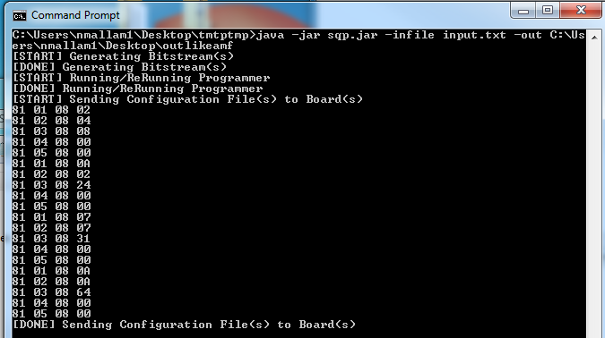

**Verify Bitgen is generated:**

Go to out/mult8x8/testsuite1/_scratch/impl1 to verify that the bit file is generated

---OR---

Go to out/mult8x8/testsuite1/logs/trunkLog.txt to see the script output

**Verify Programmer worked:**

If the LED light is blinking on the board

----OR----

Go to out/mult8x8/testsuite1/logs/ProgrammerOutput.txt to see the programmer log

**Verify the conf file (stimulus package) has been sent to board:**

Go to out/mult8x8/testsuite1/logs/ftdiLog.txt to see the log  
---AND----  
look at the console output